Result Analysis of Assignment 3

part A

1. 127.0.0.1

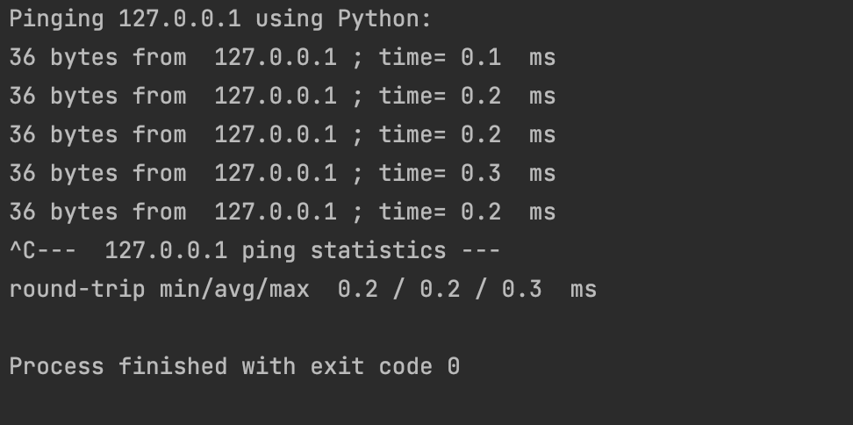

1. cs.stonybrook.edu

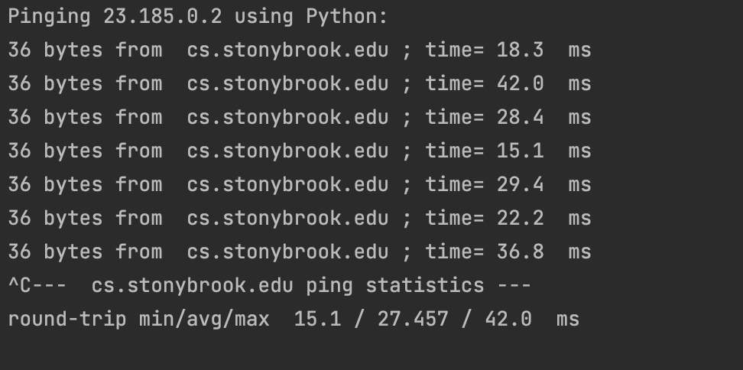

1. root server outside of U.S.

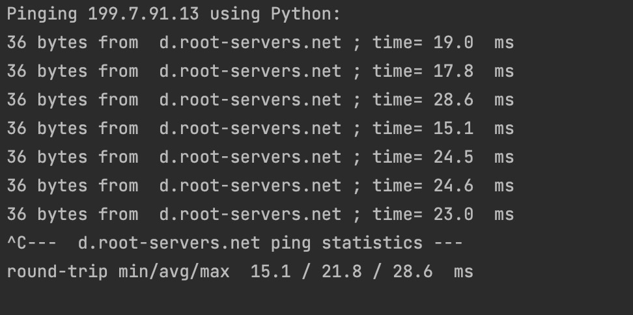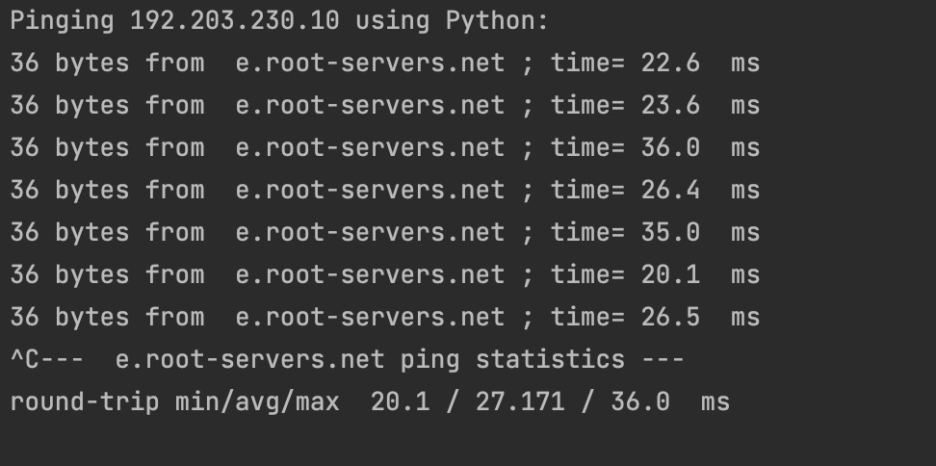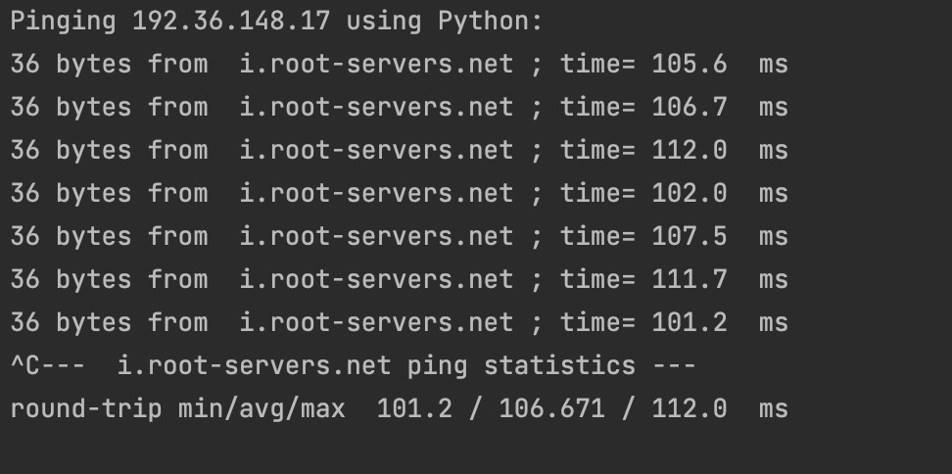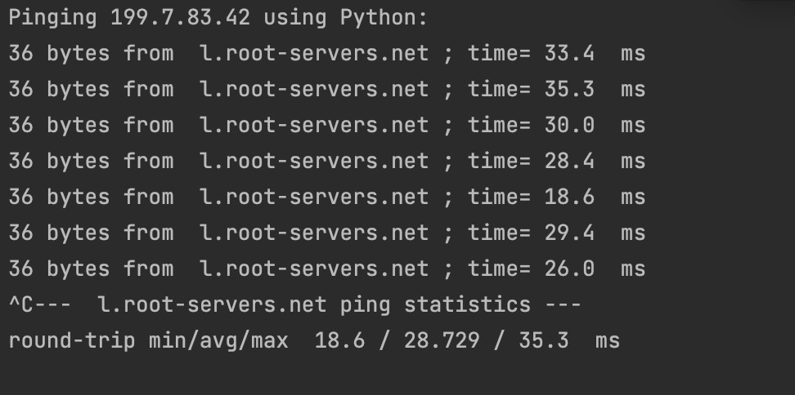

1. explanation

The RTT time is related to the distance between the sender to the receiver. So, the longer the distance is, the larger RTT is. 127.0.0.1 is a reserved IP address corresponding to the host computer and is the closest to the local. cs.stonybrook.edu is in the United State which is closer to the location of the host than those root server outside the US. Thus, those root server outside of the US would have the longest distance and longest delay.

Part B

The IP address of my router is 192.168.1.1 and the Mac address of my router is Sagemcom_79:84:1a (44:ad:b1:79:84:1a). When I browse the Web, the Wireshark capture the ARP packet exchange from local and global. My router send ARP requests as broadcast and ARP replies are uni-cast. So I determine that my router in the sender of the ARP request.